**Excle Lab2 Assignment**

INDEX and MATCH functions

Worksheet: SalesData

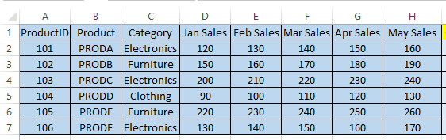

Q1.Use INDEX and MATCH to find the sales for Product C in March.

Ans: =INDEX(D2:H7,MATCH("PRODC",B2:B7,0),MATCH("Mar Sales",D1:H1,0))

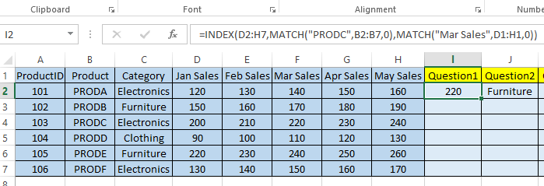

Q2. Use INDEX and MATCH to find the category for Product E.

Ans: =INDEX(C2:C7, MATCH("PRODE", B2:B7, 0))

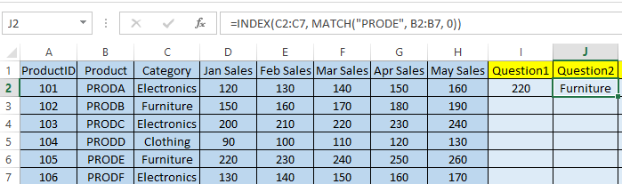

3. Use INDEX and MATCH to find the maximum sales for Product B across all months.

Ans: =MAX(INDEX(D2:H7, MATCH("PRODB", B2:B7, 0), 0))

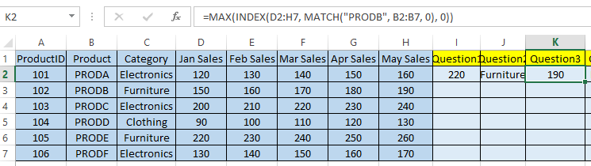

4. Use INDEX and MATCH to find the month with the maximum sales for Product A.

Ans: =INDEX(D1:H1, MATCH(MAX(INDEX(D2:H7, MATCH("PRODA", B2:B7, 0), 0)), INDEX(D2:H7, MATCH("PRODA", B2:B7, 0), 0), 0))

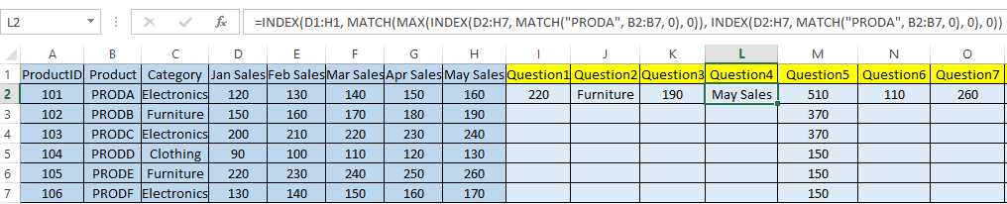

5. Use INDEX, MATCH, and SUMIF to sum the sales for all products in the "Electronics" category for April.

Ans: =SUMIF(C2:C7, "Electronics", F2:F7)

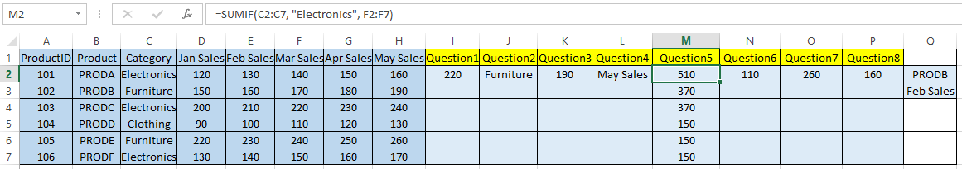

6. Use INDEX and MATCH to calculate the average sales for Product D across all months.

Ans: =AVERAGE(INDEX(D2:H7, MATCH("PRODD", B2:B7, 0), 0))

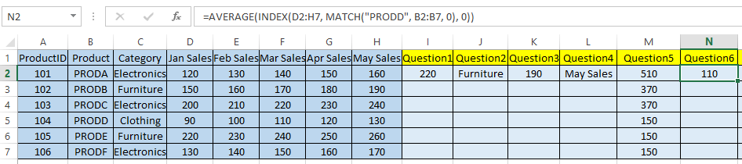

7. Use INDEX and MATCH to find the sales for Product ID 105 in May.

Ans: =INDEX(H2:H7, MATCH(105, A2:A7, 0))

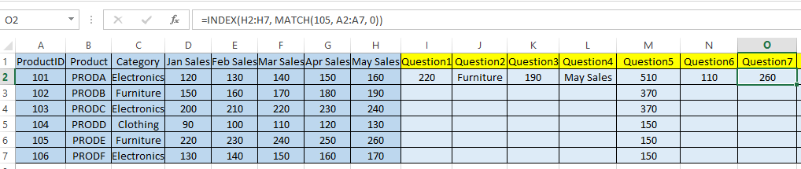

8. Use INDEX and MATCH to create a dynamic lookup where the user can input a product and a month, and the formula returns the corresponding sales

Ans: =INDEX(D2:H7, MATCH(Q2, B2:B7, 0), MATCH(Q3, D1:H1, 0))

